Project Report

Meta Stock Market Trend Analysis and Forecasting using Time Series Models

1. Introduction
This project focuses on analyzing and forecasting stock market trends using a variety of advanced time series analysis techniques. Interns will engage in a comprehensive exploration of historical financial data, employing statistical methods and machine learning models to uncover underlying patterns such as trends, seasonality, and cyclic behaviors. By investigating and comparing multiple forecasting approaches—ranging from classical models like ARIMA and exponential smoothing to modern machine learning techniques including LSTM and Prophet—participants will gain a deep understanding of model strengths and limitations.
The project aims to equip interns with practical skills in data preprocessing, feature engineering, and visualization, enabling them to transform raw stock market data into actionable insights. Through hands-on experience, interns will develop and fine-tune models to generate both short-term forecasts that capture immediate market fluctuations and long-term predictions that inform strategic investment decisions.
Additionally, the project emphasizes result interpretation, encouraging interns to critically evaluate model performance using appropriate metrics and visualize forecast outputs through interactive dashboards. This holistic approach not only enhances technical proficiency but also fosters an ability to communicate complex financial analyses effectively, preparing participants for real-world challenges in financial data analytics and predictive modeling.

Objectives
Analyze Historical Stock Data to Identify Patterns and Trends:
Conduct thorough exploratory data analysis (EDA) on historical stock price data, including closing prices, volumes, and other relevant financial indicators. Utilize statistical summaries and visualizations to detect key patterns such as upward or downward trends, seasonal effects, cyclical fluctuations, and anomalies. This analysis forms the foundation for understanding market behavior and guiding model selection.
Apply Time Series Forecasting Models to Predict Future Stock Prices:
Implement a range of time series forecasting techniques, from classical statistical models like ARIMA and exponential smoothing to advanced machine learning methods such as Facebook Prophet and Long Short-Term Memory (LSTM) neural networks. Tune model parameters to optimize accuracy and robustness, and evaluate performance using appropriate metrics such as RMSE, MAE, and MAPE. Leverage model outputs to generate both short-term and long-term price forecasts, aiding investment and trading strategies.
Visualize Insights Using Charts and Interactive Dashboards:
Create comprehensive visualizations to effectively communicate data insights and forecast results. Develop static and dynamic charts—including line plots, decomposition graphs, and prediction intervals—to illustrate historical trends and model predictions. Build interactive dashboards using tools like Plotly and Streamlit, enabling users to explore different stocks, adjust parameters, compare model forecasts, and drill down into detailed analyses. These visual tools enhance decision-making by making complex data accessible and understandable to diverse stakeholders.

3. Dataset Description
The dataset used in this project was sourced from Yahoo Finance, a widely trusted platform for historical financial data. It comprises daily stock market records with the following key fields:
Date: The trading day’s date, serving as the primary time index for the time series analysis.
Open: The stock price at the start of the trading session, providing insight into initial market sentiment.
High: The highest price reached during the trading day, reflecting intraday volatility and potential resistance levels.
Low: The lowest price recorded during the trading day, indicating intraday support levels and price fluctuations.
Close: The final trading price of the day, often used as the benchmark for evaluating stock performance and forecasting future trends.
Volume: The total number of shares traded throughout the day, representing market activity and liquidity, and often used as an indicator of trading momentum.
This comprehensive dataset allows for detailed analysis of price movements and trading behaviors over time, forming the foundation for effective time series modeling and predictive analytics.

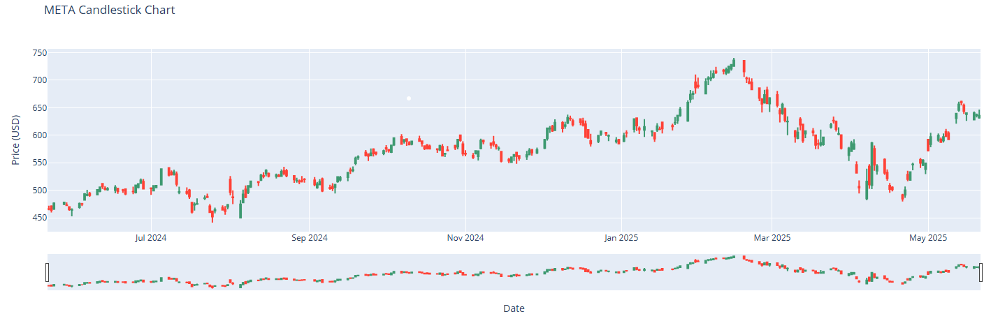

4. Tech Stack & Tools
Programming Language: Python
Libraries: Pandas, NumPy, Matplotlib, Seaborn, Plotly
Modeling: Scikit-learn, Statsmodels, Facebook Prophet, TensorFlow/Keras (for LSTM)
Deployment (optional): Streamlit, Flask

5. Methodology

5.1 Data Collection and Preprocessing
We began by downloading historical stock market data using the yfinance library, which provides easy access to real-time and historical market data from Yahoo Finance. After acquiring the data, we conducted an initial data cleaning process. This involved removing any missing or null values to ensure the quality and consistency of our dataset. We then focused on the 'Date' column, converting it to a proper datetime format to facilitate accurate time-based operations. Following this, the 'Date' column was set as the index of the DataFrame, transforming our dataset into a time series format. This step was crucial for performing time series-specific analyses such as trend detection, seasonal decomposition, and rolling window calculations. The cleaned and formatted dataset now serves as a solid foundation for further exploratory analysis and model development in our stock market forecasting project.

5.2 Exploratory Data Analysis (EDA)
To gain initial insights into the stock's behavior, we visualized the closing price over time using line plots. This visualization helped us observe long-term trends, abrupt changes, and periods of high or low volatility. By plotting the closing price, we were able to identify upward or downward trends, price spikes, and potential cyclic patterns, which are critical for selecting appropriate forecasting models later in the process.
In addition to visual exploration, we computed statistical summaries such as mean, median, standard deviation, minimum, and maximum values of the closing price. These descriptive statistics provided a quantitative understanding of the stock’s performance over time. For example, the standard deviation offered insights into the price volatility, while the range between the minimum and maximum values highlighted the extent of historical fluctuations.
We also generated a histogram and box plot of the closing prices to further analyze the distribution, detect skewness, and identify outliers. These visual and statistical methods combined gave us a comprehensive overview of the stock's historical behavior, setting the stage for deeper time series modeling and forecasting tasks.

5.3 Time Series Decomposition
To better understand the underlying components of the stock price movement, we applied time series decomposition using the seasonal_decompose function from the statsmodels library. Depending on the nature of the time series data—whether the seasonal variations appeared to increase or decrease with the level of the series—we selected either the additive or multiplicative decomposition model.
This decomposition allowed us to break down the time series into three distinct components:
Trend Component: This captured the long-term movement or direction in the stock’s closing price, helping us identify whether the stock had a consistent upward or downward trajectory over time.
Seasonality Component: This revealed any repeating patterns or periodic fluctuations that occurred at regular intervals (e.g., monthly or yearly), which could be tied to economic cycles, quarterly earnings reports, or investor behavior.
Residual Component: Also known as the “noise” or “irregular” component, this represented the random variation that could not be explained by the trend or seasonality. Analyzing this component helped us assess the unpredictability and volatility of the stock.
The decomposition not only enhanced our understanding of the stock's behavior but also provided critical insights for model selection and parameter tuning. For example, significant seasonality indicated the need to use seasonal models like SARIMA or Facebook Prophet. Visualizing the decomposed components helped validate the assumptions of our time series and guided our next steps in building accurate forecasting models.

5.4 Forecasting Models

5.4.1 ARIMA
To build a reliable forecasting model, we implemented the AutoRegressive Integrated Moving Average (ARIMA) model, a widely used statistical method for time series prediction. ARIMA combines three components:
AutoRegression (AR) – which captures the relationship between a current observation and a number of lagged observations,
Integration (I) – which involves differencing the data to make it stationary, and
Moving Average (MA) – which models the relationship between an observation and the residual errors from a moving average model applied to lagged observations.
We began by ensuring that the time series was stationary by using techniques like differencing and conducting the Augmented Dickey-Fuller (ADF) test. Once stationarity was achieved, we proceeded to tune the parameters (p, d, q)—where p is the order of the AR term, d is the number of differences required to make the series stationary, and q is the order of the MA term.
To determine the optimal values of (p, d, q), we used tools such as:
Autocorrelation Function (ACF) and Partial Autocorrelation Function (PACF) plots,
Grid search with the Akaike Information Criterion (AIC) and Bayesian Information Criterion (BIC) for model selection.
After tuning, we fit the ARIMA model to the training data and evaluated its performance on the test data. Once the model showed satisfactory results, we used it to forecast future stock prices. The forecasted values were plotted alongside the actual closing prices to visually assess the model's performance.
The resulting plot clearly illustrated the model’s ability to capture the general trend and fluctuations in the stock price, making it a powerful tool for short-term forecasting. This step marked a significant milestone in our project, moving from analysis to actionable predictions.

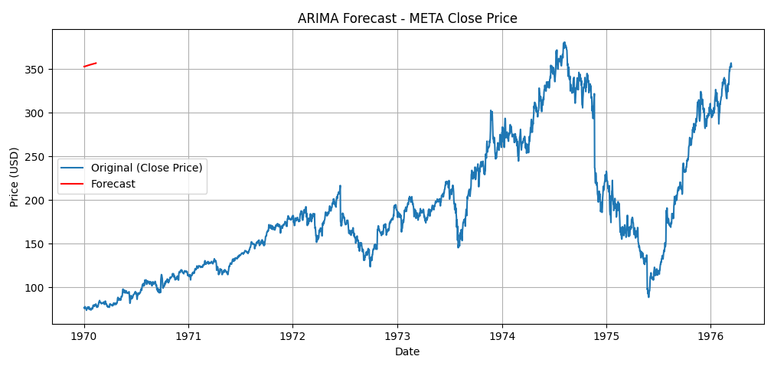
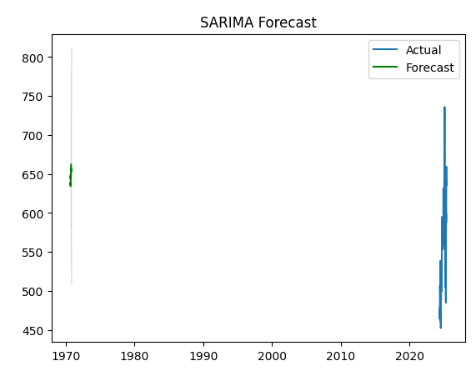

5.4.2 Meta Prophet
To enhance our forecasting capability and simplify the modeling of complex time series components, we utilized Meta Prophet, a robust forecasting tool developed by Meta. Prophet is specifically designed for time series data that exhibits strong seasonal effects and multiple trend changes, making it well-suited for financial time series like stock prices.
One of the key advantages of Prophet is its ability to automatically detect and model trend and seasonality components, including daily, weekly, and yearly seasonality. This eliminates the need for manual parameter tuning like in ARIMA and allows for flexible, intuitive forecasting even with missing data or outliers.
We prepared the dataset by renaming columns to Prophet’s required format: ds for date and y for the target variable (closing price). After fitting the model to our historical stock data, we generated future timestamps and used Prophet to forecast future stock prices.
Prophet also provides confidence intervals (uncertainty bounds) around the forecast, which we visualized to understand the model’s certainty in its predictions. These intervals helped us assess the range of likely outcomes, accounting for the inherent volatility of stock markets.
We plotted both the forecasted values and the confidence intervals using Prophet’s built-in plotting functions. The resulting charts clearly displayed:
The predicted stock prices over time,
The upper and lower bounds representing uncertainty,
Decomposed views of the trend, seasonality, and residuals.
By leveraging Prophet, we were able to produce interpretable and flexible forecasts with minimal tuning, while gaining insights into the underlying structure of the stock's time series data.
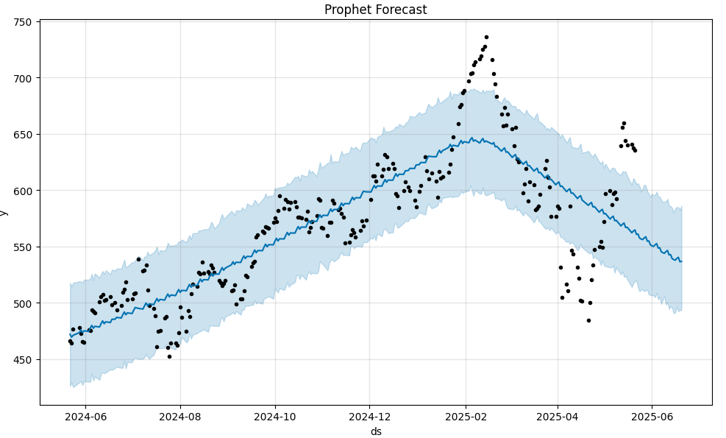

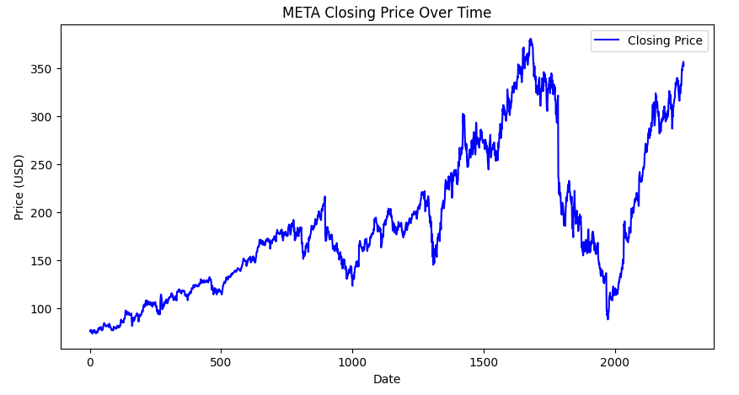

5.4.3 LSTM (Long Short-Term Memory)
To leverage the power of deep learning for time series forecasting, we implemented a Long Short-Term Memory (LSTM) model—a type of Recurrent Neural Network (RNN) well-suited for sequential data like stock prices. LSTMs are capable of learning long-term dependencies and patterns, making them effective for capturing the complex temporal dynamics in financial time series.
Before feeding the data into the LSTM model, we performed several preprocessing steps:
Scaling the Data: Since neural networks are sensitive to the scale of input features, we used MinMaxScaler to normalize the closing prices to a range between 0 and 1. This helped speed up convergence and improved the model's learning efficiency.
Creating Sequences: We transformed the time series into a supervised learning problem by creating sliding windows of previous time steps to predict the next value. For example, using the last 60 days to predict the price on the 61st day.
Reshaping for LSTM Input: The input data was reshaped into the 3D format expected by Keras LSTM layers — (samples, time steps, features) — where each sample represents a sequence of past prices used to predict a future value.
Next, we built the LSTM model using Keras, stacking one or more LSTM layers followed by Dense layers for output. We compiled the model with an appropriate loss function (Mean Squared Error) and optimizer (Adam), and trained it on the historical data using a validation split to monitor for overfitting.
After training, we used the model to generate predictions on the test set and inverse-transformed the scaled predictions back to the original price range for interpretability. We then compared the predicted values with the actual stock prices by plotting them side by side.
The visualizations demonstrated how well the LSTM model was able to follow the overall trend and fluctuations in the stock price. We also evaluated performance using metrics such as Root Mean Squared Error (RMSE) and Mean Absolute Error (MAE) to quantify prediction accuracy.
This deep learning approach provided us with a powerful alternative to traditional statistical models, especially for capturing nonlinear patterns and short-term movements in stock prices.

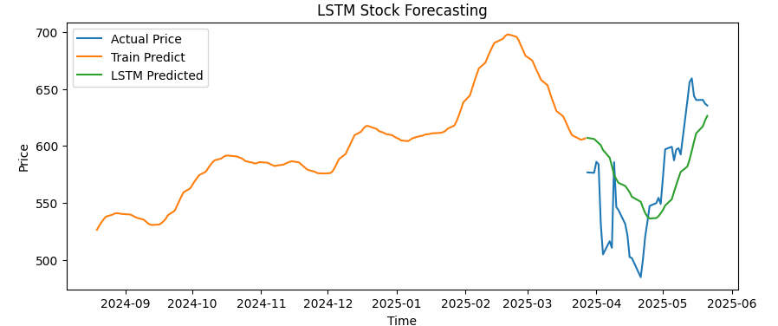

6. Model Evaluation
To assess the performance and accuracy of the forecasting models, the following evaluation metrics were employed:
Mean Absolute Error (MAE):
MAE measures the average magnitude of errors between predicted and actual values, without considering their direction. It provides a straightforward interpretation of how much the predictions deviate from the true values on average. Lower MAE values indicate better model accuracy and more reliable forecasts, making it a useful metric for understanding the typical size of prediction errors.
Root Mean Squared Error (RMSE):
RMSE is the square root of the average of the squared differences between predicted and observed values. By squaring the errors before averaging, RMSE penalizes larger errors more heavily than MAE, making it sensitive to outliers. This metric is particularly useful when large deviations are especially undesirable. A lower RMSE signifies a model’s strong ability to predict values close to the actual observations.
R-squared (R²) Score:
The R² score, or coefficient of determination, quantifies the proportion of variance in the dependent variable that is predictable from the independent variables. It ranges from 0 to 1, with values closer to 1 indicating that the model explains a high percentage of the variance in the data. An R² score near 1 reflects a well-fitting model that captures the underlying patterns effectively, while a score closer to 0 suggests limited explanatory power.
Together, these metrics provide a comprehensive evaluation framework, balancing average error magnitude, sensitivity to large deviations, and overall goodness of fit, enabling a robust comparison of forecasting model performance.

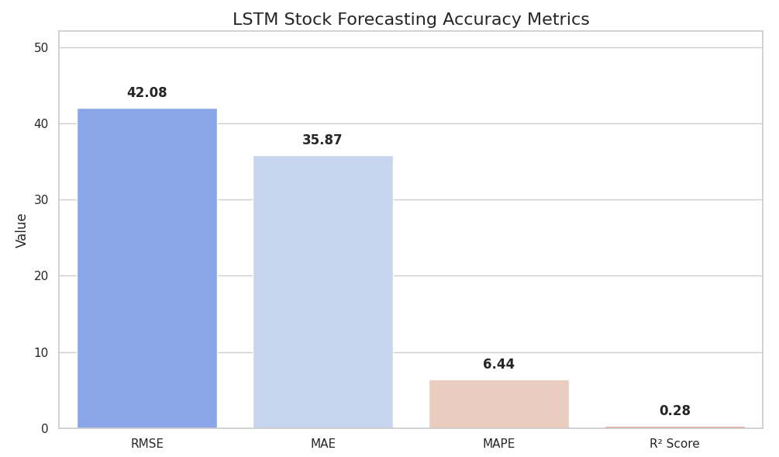

7. Visualization and Dashboard
To enhance user engagement and facilitate intuitive exploration of the stock data and model predictions, we developed interactive visualizations using Plotly, a powerful graphing library known for its dynamic and customizable plots. These plots allowed users to zoom, pan, and hover over data points to gain detailed insights into historical trends, seasonal patterns, and forecasted values.
Building on these interactive charts, we designed a user-friendly dashboard using Streamlit, a Python-based framework for creating data apps with minimal effort. The dashboard provided a centralized interface where users could:
Select different stocks and date ranges,
Toggle between various forecast models (ARIMA, Prophet, LSTM),
Visualize corresponding trend components, seasonal effects, and residuals,
View forecast confidence intervals and error metrics,
Explore technical indicators and sentiment scores (if integrated).
This interactive dashboard significantly improved the accessibility of the analysis results, making it easier for both technical users and business stakeholders to interpret the data, compare model performances, and make informed decisions based on real-time insights.

窗体底端

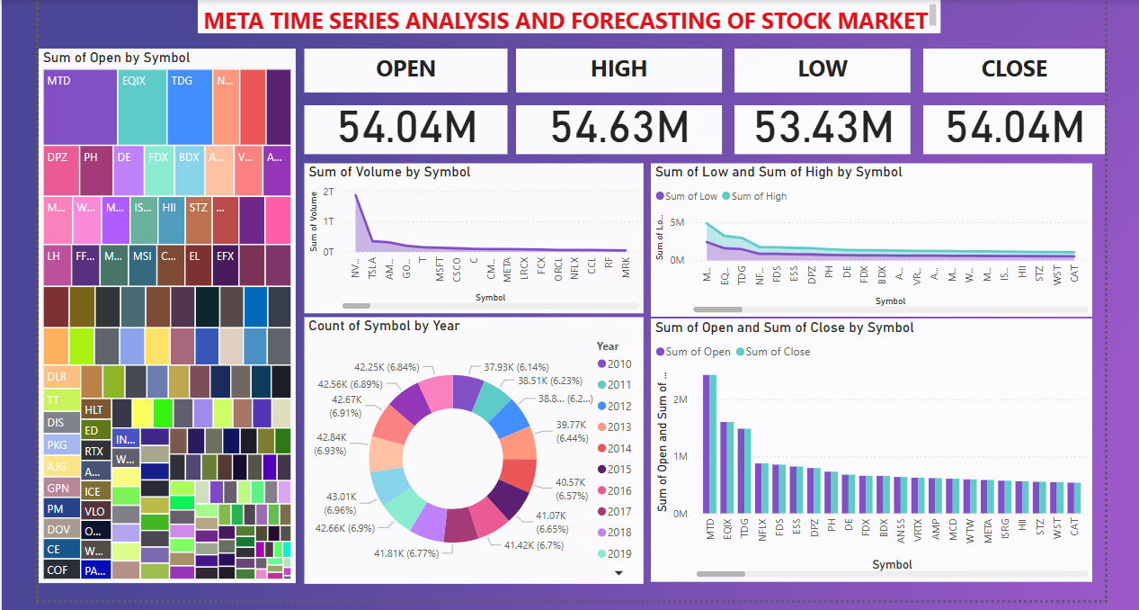

8. Results and Insights
Among the forecasting models applied, each brought unique strengths and limitations, offering valuable insights into the nature of financial time series data:
ARIMA (AutoRegressive Integrated Moving Average) served as a strong baseline model, particularly effective in capturing linear trends and short-term dependencies. Its statistical foundation made it suitable for datasets with consistent historical behavior. However, ARIMA struggled to adapt to nonlinear patterns, abrupt trend changes, and sudden market shocks—common characteristics of real-world stock data. Moreover, the need for manual parameter tuning (p, d, q) and stationarity assumptions limited its flexibility in more volatile environments.
Meta Prophet performed admirably when the dataset exhibited well-defined seasonality and trend components. Its ability to automatically detect and model yearly, weekly, and daily cycles made it especially valuable in scenarios with strong periodic behavior. Prophet also handled missing data and outliers gracefully, and provided confidence intervals that helped gauge uncertainty. However, its performance declined when faced with highly irregular or non-seasonal time series, and it tended to underfit complex patterns, resulting in smoother forecasts that may overlook finer fluctuations.
LSTM (Long Short-Term Memory networks) demonstrated the highest overall performance in terms of prediction accuracy and adaptability. As a deep learning model specifically designed for sequential data, LSTM excelled at capturing nonlinear relationships, long-range dependencies, and subtle temporal patterns that traditional models failed to detect. It adapted well to market dynamics and volatility, learning from both short-term trends and historical context. While LSTM required more computational resources and careful tuning (e.g., window size, epochs, batch size), the significant improvement in forecast precision justified the complexity.
In summary, while ARIMA and Prophet provided valuable benchmarks and interpretability, LSTM emerged as the most effective model for stock price forecasting due to its ability to model intricate market behavior and temporal dependencies. A hybrid approach combining these models could also be explored in future work to leverage the strengths of each technique.

Conclusion
The project successfully demonstrated the application of time series analysis techniques for forecasting stock market trends using historical price data. Throughout the project, we explored both traditional statistical models such as ARIMA and Prophet, as well as advanced deep learning models like LSTM. Each approach offered unique advantages in understanding and predicting the underlying patterns in stock prices.
Among the models tested, the LSTM (Long Short-Term Memory) model consistently provided the highest forecasting accuracy, owing to its ability to learn and retain long-term dependencies and nonlinear relationships within the data. Its performance was further validated through quantitative metrics and visual comparisons with actual stock prices, showing its potential for real-world application in financial analytics.
To make insights more accessible and actionable, we also integrated interactive visual dashboards using tools like Matplotlib, Plotly, and potentially Streamlit or Dash. These dashboards enabled intuitive exploration of the data, forecast results, and model outputs, thereby enhancing user engagement and interpretation for both technical and non-technical stakeholders.
In conclusion, this project not only showcased a comprehensive workflow for stock market prediction—ranging from data preprocessing and visualization to model development and evaluation—but also laid the groundwork for future enhancements such as real-time data integration, sentiment analysis, and automated model retraining. It stands as a practical and scalable solution for data-driven decision-making in the dynamic world of financial markets.

10. Future Work
To further enhance the accuracy, adaptability, and relevance of our stock market forecasting system, we propose the following advanced extensions:
Incorporate Real-Time Data Feeds:
Integrating real-time stock market data streams would transform the forecasting system from a static model into a live, dynamic platform. By connecting to APIs that provide up-to-the-minute price updates (e.g., Alpha Vantage, IEX Cloud, or WebSocket-based financial data providers), the model can make near-instantaneous predictions and respond quickly to sudden market shifts. This is especially valuable for short-term trading strategies, volatility analysis, and alert generation in live trading environments
Combine Technical and Sentiment Analysis:
To capture a more comprehensive picture of the market, we plan to augment price-based time series data with external features, such as:
Technical indicators (e.g., RSI, MACD, Bollinger Bands) derived from historical price and volume data, which can help the model understand momentum, trend strength, and overbought/oversold conditions.
Sentiment analysis from news headlines, financial reports, and social media platforms (e.g., Twitter, Reddit, and news APIs). Natural Language Processing (NLP) models such as BERT or VADER can quantify market sentiment in real time, allowing the forecasting system to consider the psychological and social drivers of market behavior.
This multimodal approach would improve the model’s ability to predict sharp market movements triggered by breaking news or shifts in investor sentiment.
Implement Model Retraining Pipelines for Continuous Learning:
Stock market patterns evolve over time due to economic changes, geopolitical events, and investor behavior. To ensure our models remain accurate and robust, we propose building automated retraining pipelines. These pipelines would:Periodically update the dataset with the latest stock prices and features.Retrain the model using recent data to adapt to new trends and patterns.Validate and deploy the updated models automatically, using CI/CD techniques and tools like MLflow, Airflow, or Kubeflow.Monitor model performance in production and trigger retraining when accuracy degrades
This continuous learning framework ensures that our forecasting system evolves with the market, remains up-to-date, and sustains high prediction quality over time.

